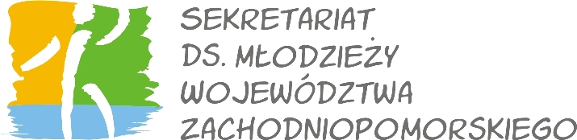

InterCoNnEcTion in Diversity
Study Visit, Youth Educational Center in Oberschleißheim near Munich, Germany, 1-5 March 2012

1. Personal data
Surname: ________________________________ First name: __________________________________
□ Male □ Female
Address: ______________________________________________________________________________
Telephone: ____________________________ Email: ___________________________________
Date of birth: ______________________ Place of birth :________________________________________
Nationality: ________________________
2. English skills (please mark with X):
Fluent in speaking and writing Communicative

3. Organization data
Institution / Organization name: ______________________________________________
Adress:
______________________________________________
Occupation:
______________________________________________
Please describe in few sentences how are you involved in working with youth at your work or organization

3. Motivation
Why do you want to participate in the project? How can you use the Betzavta method at your work, organization?

___________________________________ ______________________________________________
place, date Signature

Please send this form until 20th of January to cim@cim.info.pl.

